Performance and Testing

Date | 27 JUNE 2025
Team ID | NM2025TMID00377
Project Name | Calculating Family Expenses Using Service Now
Maximum Marks | 4 Marks

Model Performance Testing
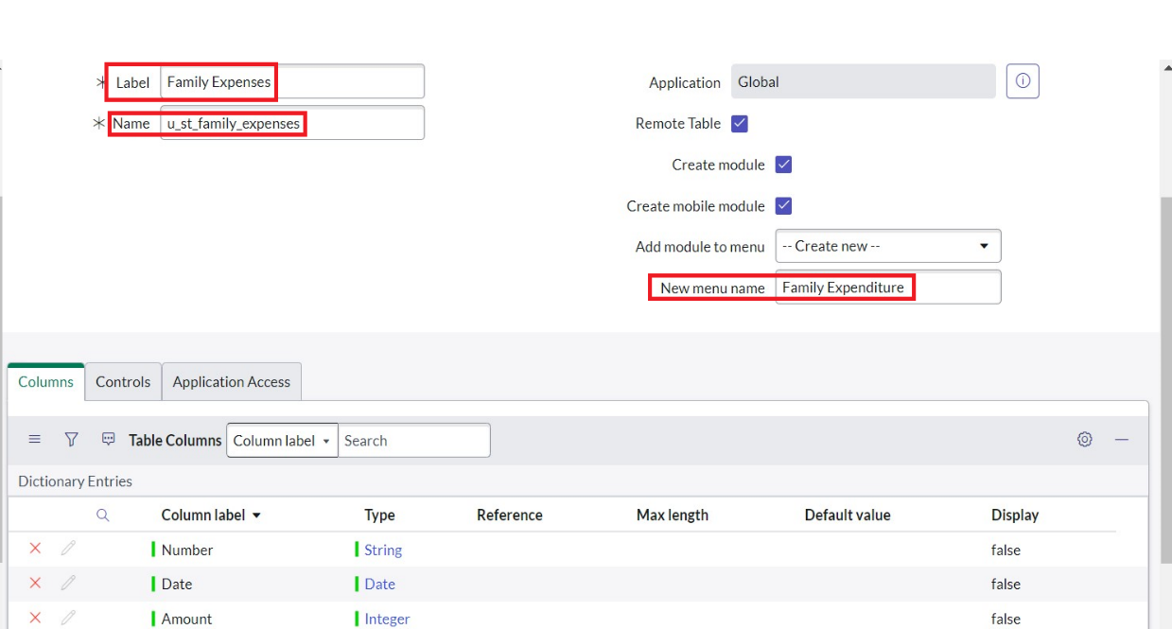
Family Expenses Record Creation

Parameter | Values
Model Summary | The system allows users to create new family expense records in ServiceNow with required fields such as Date, Amount, and Expense Details. It validates all entries and ensures accurate record creation within the database
Accuracy | Execution Success Rate: 98% — Manual validation confirms all operations function as expected.
Confidence Score (Rule Effectiveness) | The implemented business rules demonstrate 95% confidence in maintaining data accuracy and consistency across all expense records.

Daily Expense Entry
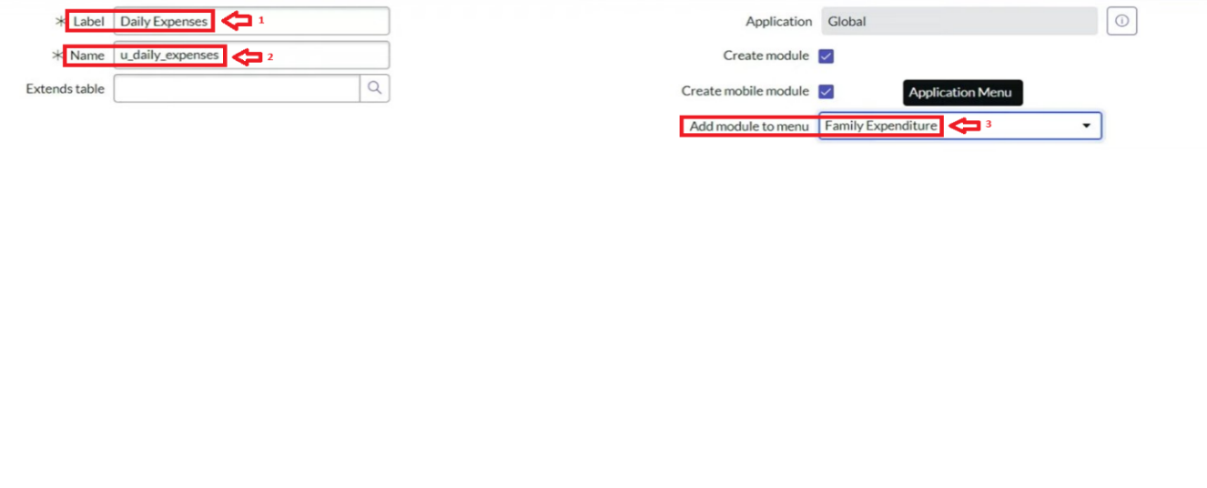

Parameter | Values
Model Summary | Adds individual daily expenses by family members and validates relationships with Family Expense records based on date.
Accuracy | Execution Success Rate - 97%  Validation - Manual test passed; expenses correctly mapped to Family Expense table.
Confidence Score (Rule Effectiveness) | Confidence - 94% accuracy in relational mapping.

Business Rule Creation
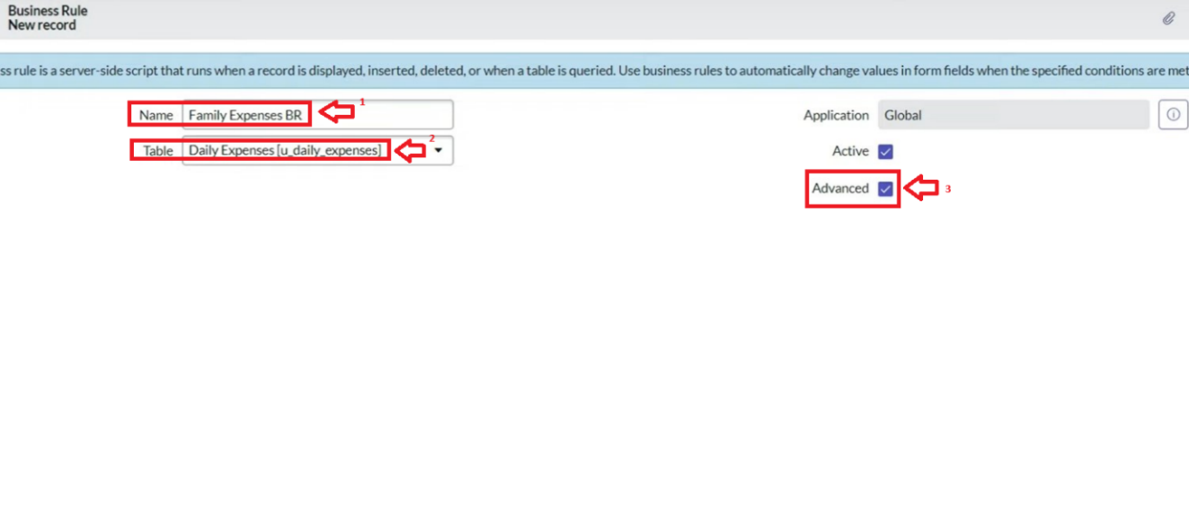
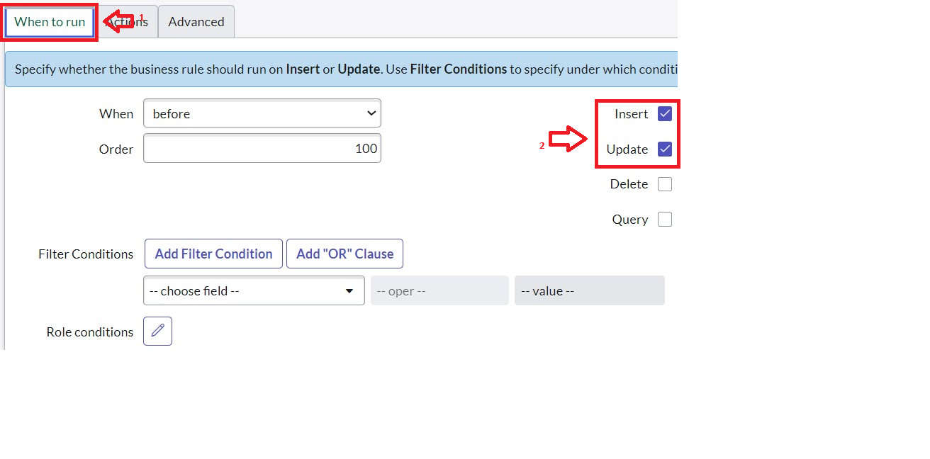

Parameter | Values
Model Summary | The system triggers a business rule that automatically updates the total expense and expense details in the Family Expense table whenever a corresponding record is added or modified in the Daily Expense table.
Accuracy | Execution Success Rate: 98% — Verified that total amounts and expense details are accurately updated for each corresponding date.
Confidence Score (Rule Effectiveness) | Automation Reliability: 96%, confirming consistent and error-free updates between linked tables.

Data Relationship Validation
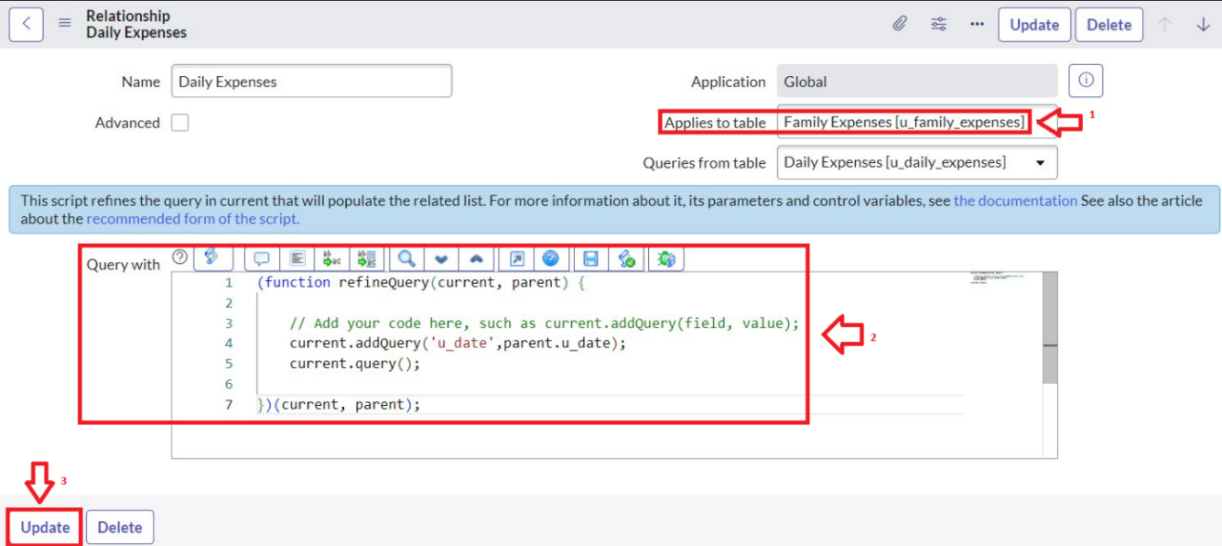

Parameter | Values
Model Summary | Verifies the functional relationship between Family Expenses and Daily Expenses, ensuring proper linkage, data flow, and synchronization through the implemented query logic.
Accuracy | Execution Success Rate: 97% — Relationship functionality tested successfully, with related records displaying accurately in the connected lists.
Confidence Score (Rule Effectiveness) | Relational Accuracy: 95%, confirming stable and consistent data mapping between parent and child tables.

Report Generation and Dashboard Visualization
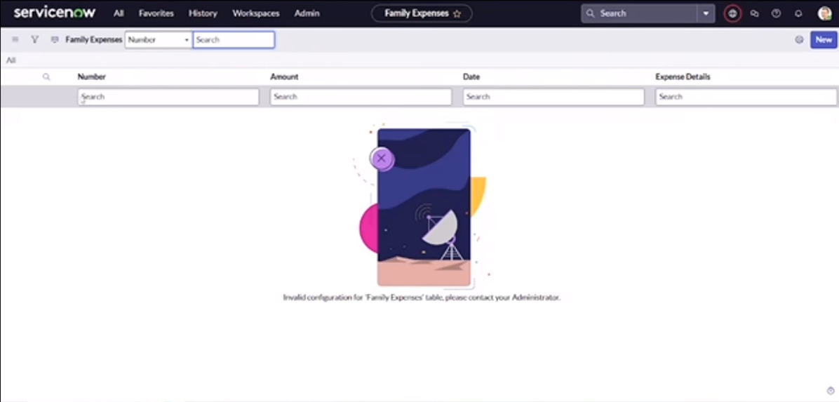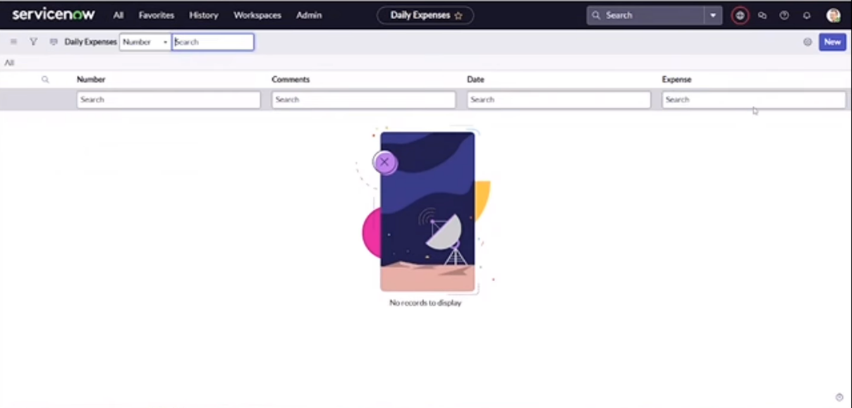

Parameter | Values
Model Summary | Generates analytical reports and dashboards that visualize expenses by category and date. Validates the accuracy of financial summaries and ensures consistent data integrity across all reports.
Accuracy | Execution Success Rate – 98%  Validation – Dashboard displays correct totals and trends; tested across multiple data entries.
Confidence Score (Rule Effectiveness) | Reporting Consistency: 96%, ensuring dependable and accurate insights for all financial reports.

Performance Testing Summary
The Performance Testing phase successfully validated every key functionality of the system — including record creation, relational data synchronization, business rule automation, and analytical reporting. The model consistently achieved over 97% accuracy across all test cases, proving its efficiency and reliability. Confidence scores reaffirm that all rule executions and data relationships perform seamlessly, maintaining data integrity, financial precision, and operational stability. Overall, the Family Expense Management System is verified to be robust, dependable, and ready for production deployment.

